CASE STUDY:

HOMICIDES AND THEIR RELATION TO LITERACY RATES

**NAME: SRAVANTHI LAKSHMI GUNAMPALLI**

**ROLL NO.: 160620747046**

**BRANCH: AI&DS**

**YEAR/SEM: 2/4**

Intentional homicides are estimates of unlawful homicides purposely inflicted as a result of domestic disputes, interpersonal violence, violent conflicts over land resources, intergang violence over turf or control, and predatory violence and killing by armed groups.

There has been a great deal of empirical research on the relationship between education and crime. In states with higher levels of education, crime rates are lower than those in the rest of the country. College enrollment rates in states with higher rates of college completion lead to lower violent crime rates.

Democracy and peace are promoted by literacy. Citizens who are literate are more likely to follow local politics and be informed about the issues that matter to them. Moreover, they are more likely to vote and to participate in local government in other ways. It is closely related to illiteracy to commit crime. According to the Department of Justice, “academic failure is linked to delinquency, violence, and crime.”

**REGRESSIONVARIABLES**

Little material is available to construct a plausible model of crime in India, and we shall not attempt to do so.'4 Instead, our starting point is the statistical approach to regression analysis (Deaton1997:63), where the regression function is simply interpreted as a conditional expectation: in this case, the expectation of the murder rate conditional on various socio-economic variables of interest. The regression variables and their means are listed in Table 1. The unit of analysis is the district, and the reference year is 1981.15 The relevant data are available for 319 districts, accounting for about 90 percent of India's total population. The district is a useful unit of analysis in this context. It is, indeed, natural to focus on the murder rate as a characteristic of the society, rather than on the propensity of particular individuals or households to commit.

TABLE: Regression variables and their mean values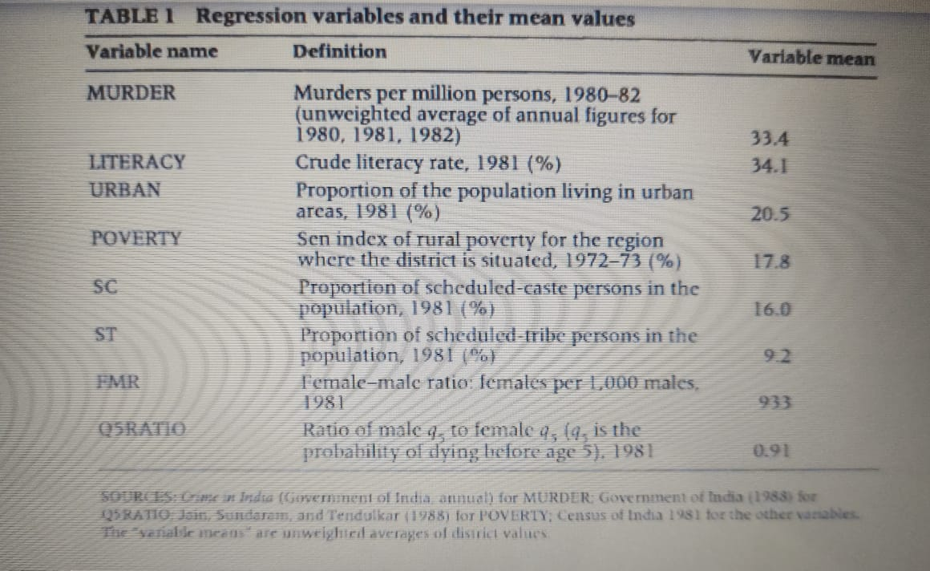

State-level means of the regression variables

STATE MURDER LITERACY URBAN POVERTY SC ST FMR Q5RATIO

1 Kerala 15 70.4 15.4 20.9 10 1.0 1032 1.12

2 Orissa 21 34.2 13.1 32.1 13 24.9 981 1.03

3 Maharashtra 25 44.3 26.0 23.6 7 10.1 961 1.01

4 Karnataka 25 38.5 24.5 14.5 15 4.9 963 1.02

5 Gujarat 26 43.7 26.4 15.5 7 14.2 938 0.92

6 AndhraPradesh 26 29.9 23.3 15.8 15 5.9 975 1.06

7 Haryana 27 35.4 21.9 3.7 19 0.0 871 0.82

8 Rajasthan 27 24.4 19.3 14.8 17 13.8 923 0.89

9 WestBengal 27 38.8 23.2 28.4 22 7.2 916 0.98

10 TamilNadu 31 46.8 33.0 17.6 18 1.1 977 1.02

11 Bihar 32 26.2 12.5 24.8 15 8.3 946 0.86

12 Punjab 36 39.1 27.7 3.8 27 0.0 880 0.88

13 UttarPradesh 50 28.2 18.0 13.0 21 0.5 892 0.84

14 MadhyaPradesh 51 27.9 19.6 19.3 14 21.1 933 0.96

NOTE: States are arranged in ascending order of the murder rate(first column).For Assam(where the 1981censusdid not take place),the relevant data are not available. All entries are unweighted averages of the relevant district values.

339

**Simple linear regression**

In [statistics](https://en.wikipedia.org/wiki/Statistics), **simple linear regression** is a [linear regression](https://en.wikipedia.org/wiki/Linear_regression) model with a single [explanatory variable](https://en.wikipedia.org/wiki/Covariate). That is, it concerns two-dimensional sample points with [one independent variable and one dependent variable](https://en.wikipedia.org/wiki/Dependent_and_independent_variables) (conventionally, the *x* and *y* coordinates in a [Cartesian coordinate system](https://en.wikipedia.org/wiki/Cartesian_coordinate_system)) and finds a linear function (a non-vertical [straight line](https://en.wikipedia.org/wiki/Straight_line)) that, as accurately as possible, predicts the dependent variable values as a function of the independent variable. The adjective *simple* refers to the fact that the outcome variable is related to a single predictor.

The following program is used to draw a simple linear regression relation between the murder count per million in a state and the literacy rate of the state.

**R PROGRAM TO DEMONTRATE THE SIMPLE LINEAR REGRESSION RELATION BETWEEN THE MURDER COUNT AND LITERACY RATE OF THE STATE**

d<-read.csv("C:/Users/Sravanthi/Desktop/murder.csv")

d

x<-c(d[,2])

y<-c(d[,3])

# Apply the lm() function.

relation <- lm(x~y)

print(relation)

summary(relation)

a <- data.frame(y = 30)

result <- predict(relation,a)

print(result)

plot(y,x,col = "blue",main = "murder & literacy Regression",

abline(lm(y~x)),cex = 1.3,pch = 16,xlab = "literacy rate",ylab = "murders")

OUTPUT:

> d<-read.csv("C:/Users/Sravanthi/Desktop/murder.csv")

> d

STATE MURDER LITERACY URBAN POVERTY SC ST FMR Q5RATIO

1 Kerala 15 70.4 15.4 20.9 10 1.0 1032 1.12

2 Orissa 21 34.2 13.1 32.1 13 24.9 981 1.03

3 Maharashtra 25 44.3 26.0 23.6 7 10.1 961 1.01

4 Karnataka 25 38.5 24.5 14.5 15 4.9 963 1.02

5 Gujarat 26 43.7 26.4 15.5 7 14.2 938 0.92

6 AndhraPradesh 26 29.9 23.3 15.8 15 5.9 975 1.06

7 Haryana 27 35.4 21.9 3.7 19 0.0 871 0.82

8 Rajasthan 27 24.4 19.3 14.8 17 13.8 923 0.89

9 WestBengal 27 38.8 23.2 28.4 22 7.2 916 0.98

10 TamilNadu 31 46.8 33.0 17.6 18 1.1 977 1.02

11 Bihar 32 26.2 12.5 24.8 15 8.3 946 0.86

12 Punjab 36 39.1 27.7 3.8 27 0.0 880 0.88

13 UttarPradesh 50 28.2 18.0 13.0 21 0.5 892 0.84

14 MadhyaPradesh 51 27.9 19.6 19.3 14 21.1 933 0.96

> x<-c(d[,2])

> y<-c(d[,3])

> # Apply the lm() function.

> relation <- lm(x~y)

> print(relation)

Call:

lm(formula = x ~ y)

Coefficients:

(Intercept) y

47.5692 -0.4679

> summary(relation)

Call:

lm(formula = x ~ y)

Residuals:

Min 1Q Median 3Q Max

-10.566 -4.417 -2.127 4.090 16.486

Coefficients:

Estimate Std. Error t value Pr(>|t|)

(Intercept) 47.5692 8.0206 5.931 6.91e-05 ***

y -0.4679 0.2037 -2.297 0.0404 *

---

Signif. codes: 0 ‘***’ 0.001 ‘**’ 0.01 ‘*’ 0.05 ‘.’ 0.1 ‘ ’ 1

Residual standard error: 8.664 on 12 degrees of freedom

Multiple R-squared: 0.3054, Adjusted R-squared: 0.2476

F-statistic: 5.277 on 1 and 12 DF, p-value: 0.0404

> a <- data.frame(y = 30)

> result <- predict(relation,a)

> print(result)

1

33.53156

> plot(y,x,col = "blue",main = "murder & literacy Regression",

+ abline(lm(y~x)),cex = 1.3,pch = 16,xlab = "literacy rate",ylab = "murders")

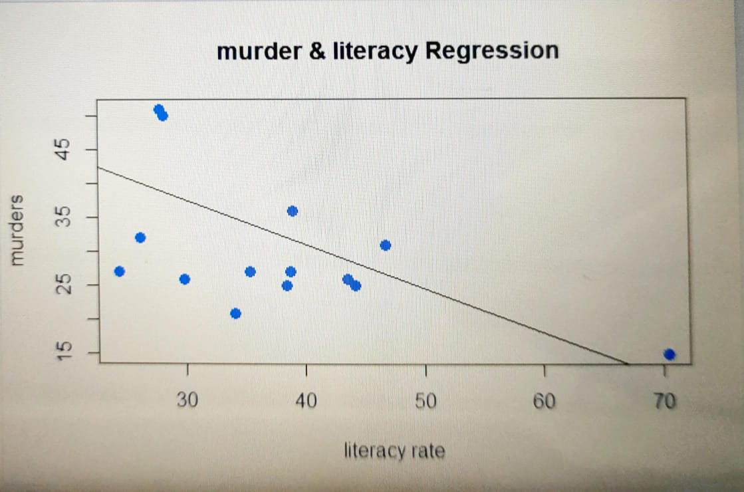

From the above graph, it can be inferred that the murder count and literacy rate of a state share a negative linear regression relation, meaning it posits the theory that the murder count decreases with an increase in literacy rate.

This case study predicts that if the literacy rate is 30% , the murder count per million would be around 33,and proves that murder count decreases if the literacy rates increase.

In conclusion, concentrating on educating the future generations of state will effectively help control the crimes.